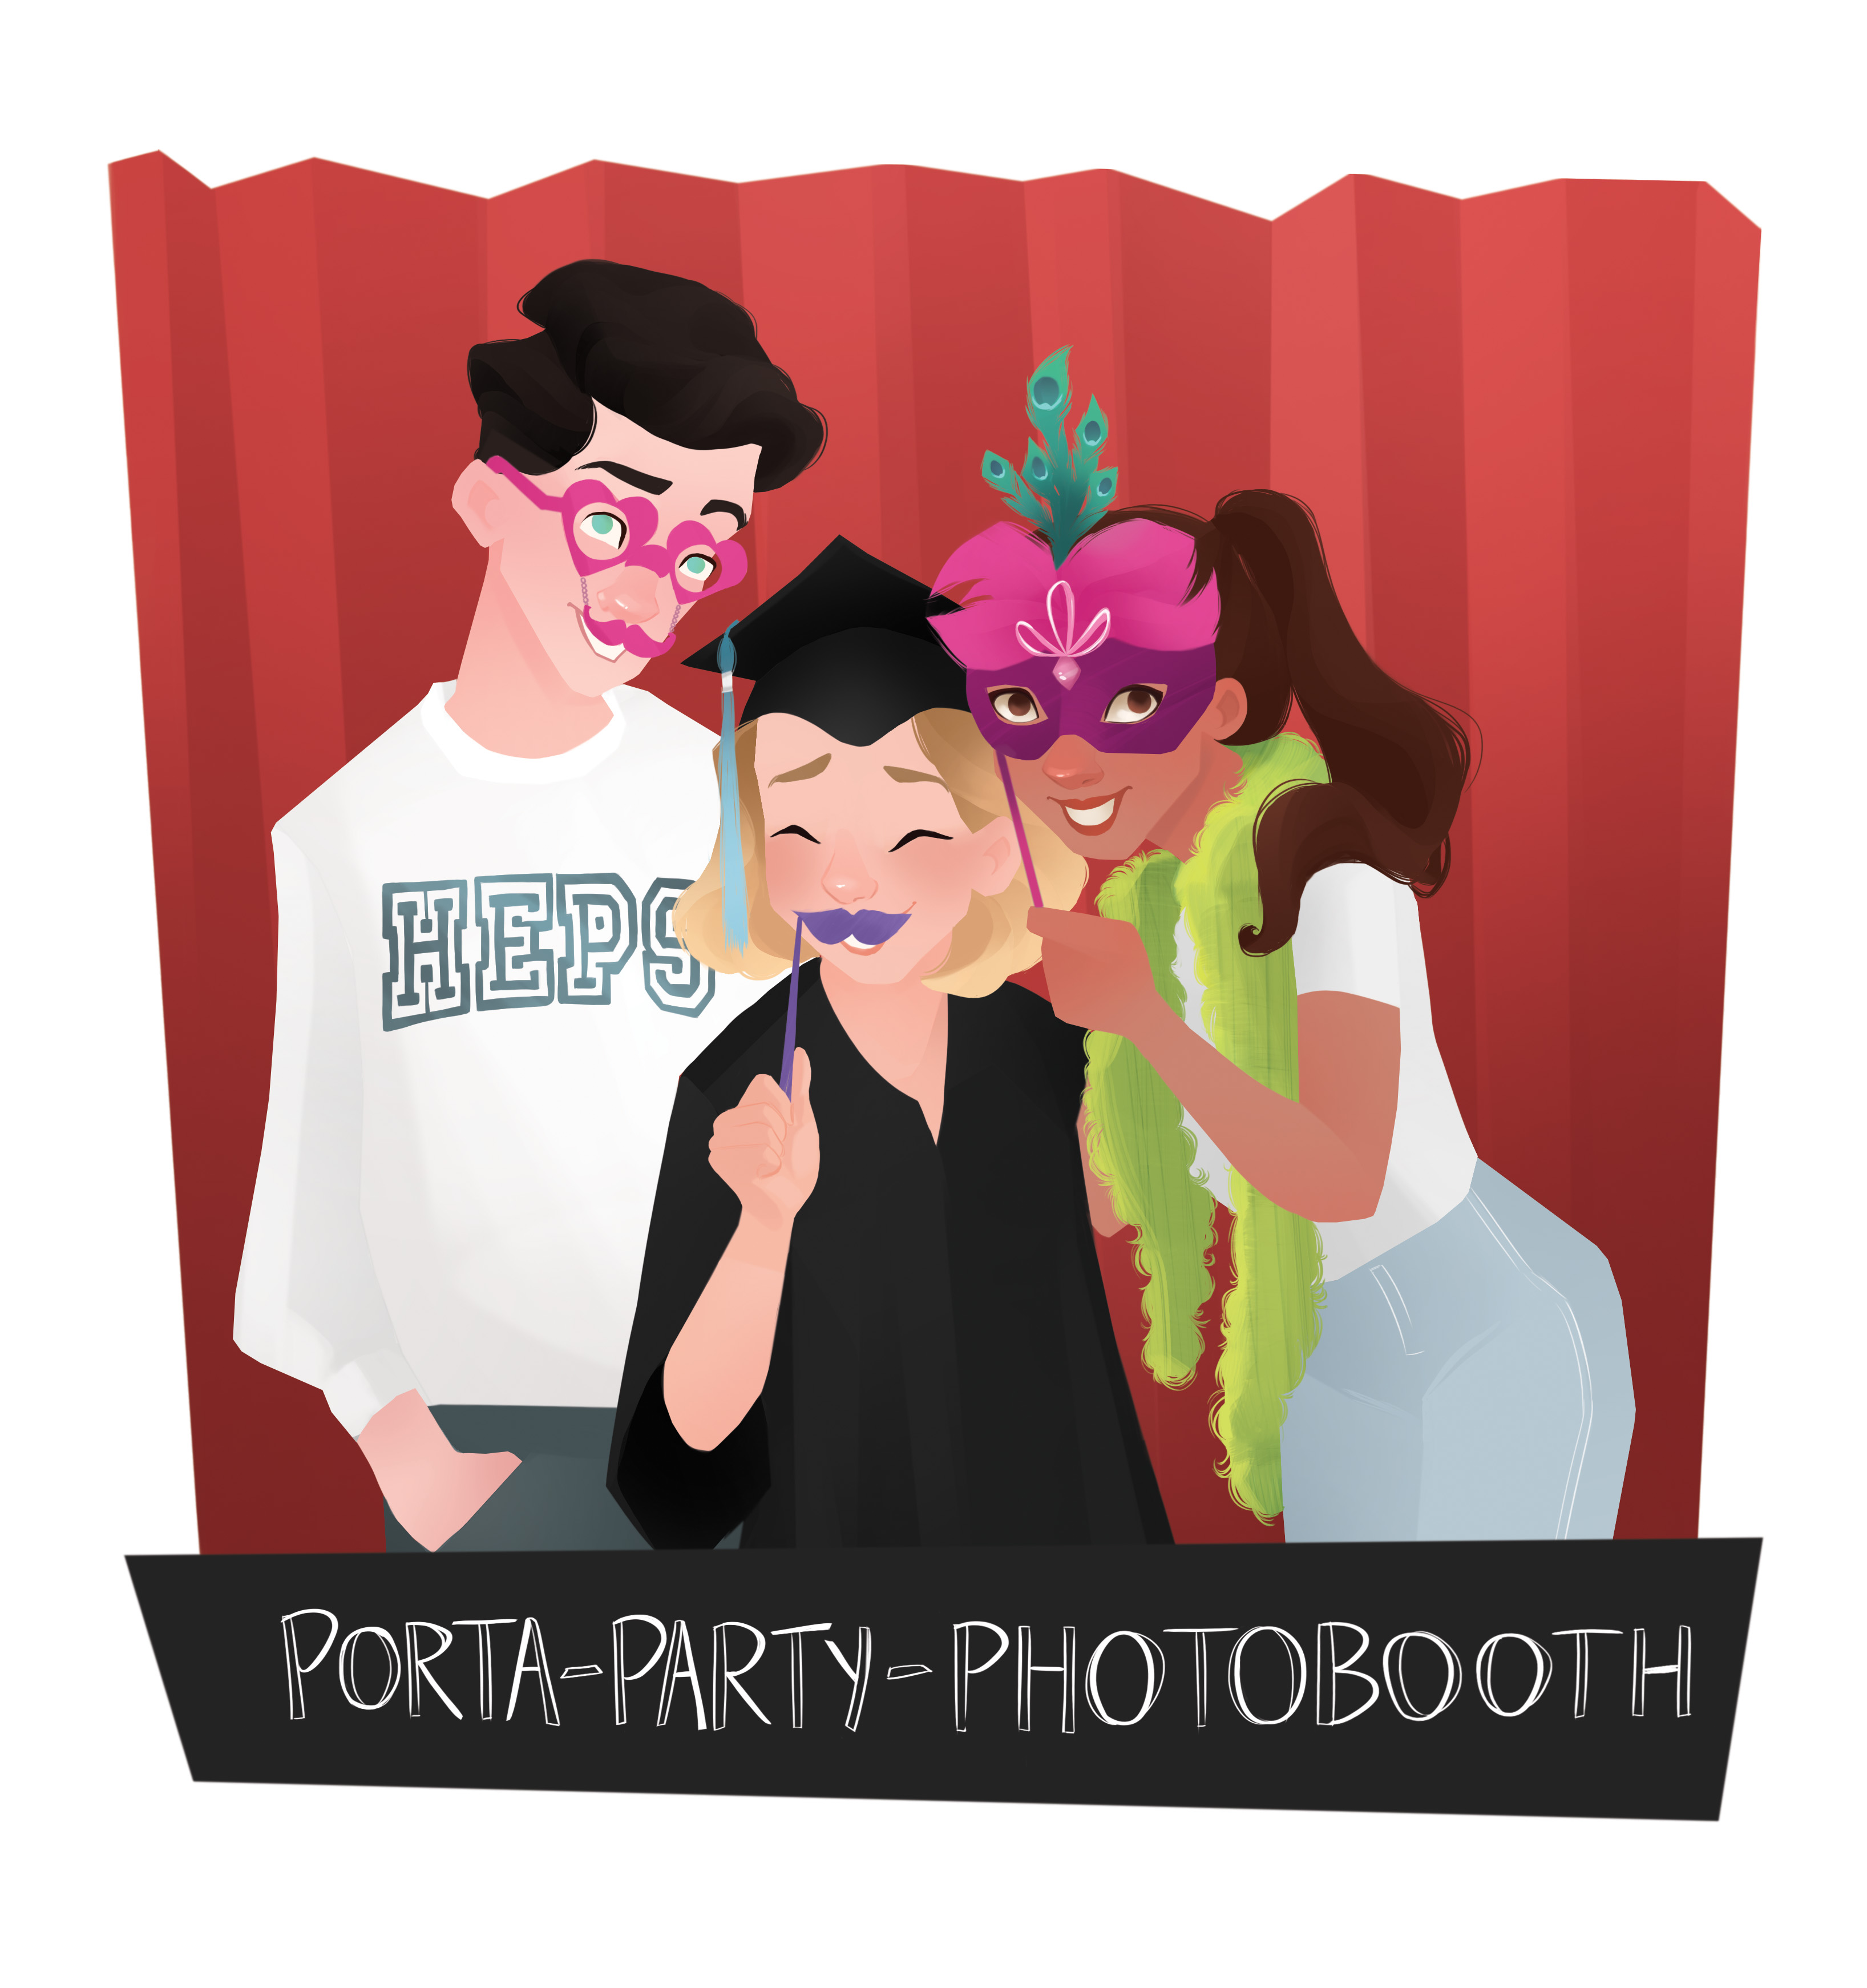
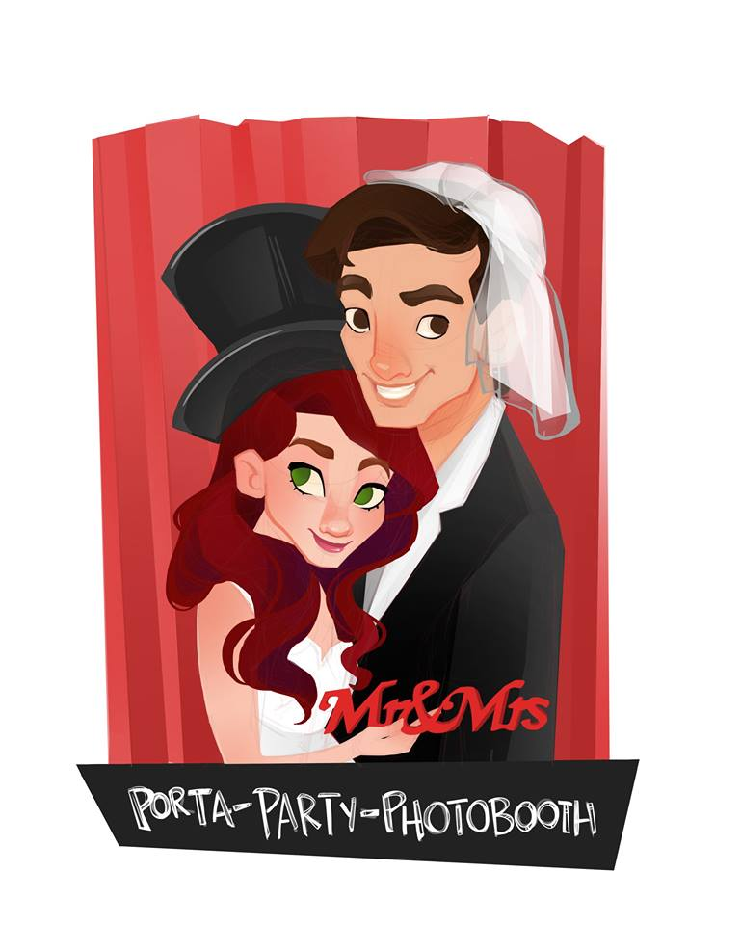
Porta Party Photobooth
Hepperle’s Event & Party Services (HEPS), Ltd.
1226 Hathaway Dr.
Colorado Springs, CO 80915
719-573-0627

Service Agreement

Client: _________________________________________________________________________________________

Phone: ______________________________________ E-Mail Address: ______________________________

Address: ______________________________________________________________________________________

Date of Event: ________________________________________________________________________________

Type of Event: _______________________________________________________________________________

Location of Event: ___________________________________________________________________________

Photo Booth Times: Total contracted time:
Start __________________ Stop ___________________

Total Fees: $________________ Deposit: $ ____________

Balance Due: $ _________ paid day of event- before set up. *please note checks do not qualify as cash payment.

Photo Booth Service Agreement

- Porta Party Photobooth agrees to provide the Client (and guests of client) entertainment services, which include rental and use of photo booth, use of props, and supervision of attendant for times specified above for the event.
- Contracted time is for a straight time block with no idle time set.
- We arrive about 30 minutes prior to start time to set up. *Please provide a 10x10 space for photo booth & leave additional space for our 6 foot prop table. Photo booth requires 9ft minimum ceilings. We also need to be within 15ft of power outlet. If proper space is not dedicated upon our arrival we will do the best we reasonably can which may result in poor picture quality and guest experience.
- All deposits are non- refundable due to cancellation for any reason. Any additional payments are not refundable if cancellation happens within 4 weeks of contracted event date.
- Outside setup is no longer accepted after 9.2.18 and we must have absolute, total indoor coverage at all times for our Photo Booth equipment.. If we must be in an area with open doors, windows or “pole barns”, coverage must be provided by client to protect electronics and attendant from sun and moisture. Additionally, full use of the photo booth experience will be diminished as we have to set restrictions on the touch screen when bugs are interfering with the touchscreen- this includes multiple pictures not being able to print for every guest, choice of color, sepia, or black & white prints. Only color prints will be the available choice for guests, initiated by the booth host for each session.
- Clients (persons who rent the use of the photo booth) are responsible for any excessive damage to props &/or photo booth by their party guests usage. Excessive damage is any damage over $25. *updated 9.2.18
- We will close the photo booth during special events (speeches, toasts, presentations, special dances, etc.) to minimize noise and out of respect of the speakers.
- Children under the age of 13 must be directly supervised by an adult age 18 or older at all times in the photo booth. We will not allow any child under the age of 13 in or around the photo booth or prop table if not directly supervised by an adult.
- At the end of the event, you will be given a CD/DVD with all the pictures from the night on it. The CD/DVD will be given the night of the event OR mailed to you after the event (within 2 weeks). You will have all rights to reprint any pictures you choose or share on social media.
- The Client agrees to pay H.E.P.S. the deposit before the event at the time of signing this contract. The Client is to pay the remaining balance at the time of set up on the contracted date or as soon as reasonably possible the day of the event. If you were given a cash discount for payment, the payment in full must be in cash to maintain that discount. If cash is not paid the original discounted amount will be added back into the total amount due. We do not accept Paypal, Venmo, or any other online cash payment system. We do accept checks, cashiers checks & credit cards but they do not qualify for the cash discount.
- All deposits are non- refundable due to cancellation for any reason. Any additional payments are not refundable if cancellation happens within 4 weeks of contracted event date.
- If payment is not paid by the end of the event, a late charge of $200.00 will be added plus 10% of the balance due for each day it is late and with reasonable attorney fees.
- In the instance that a meal is served during the event, HEPS DJ & the Photo Booth attendant would appreciate a plate.

__________________________________________ ____________________________________
Client name printed Brian or Nicole Hepperle, Owners

__________________________________________ ________________________________________
Client Signature Date Signature Date

